# Implementation 2

Implementation 1 was redone for Unity 2017 because the assets weren’t loading. The model is from standard assets. The same A* algorithm was used in this implementation with minor changes to compute total number of nodes expanded.

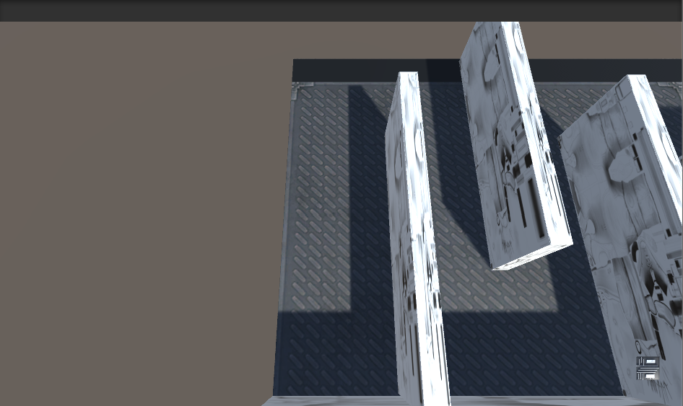

The plane is taken as a 60 x 60 grid.

Right-click anywhere on the top left area to start moving the agent.

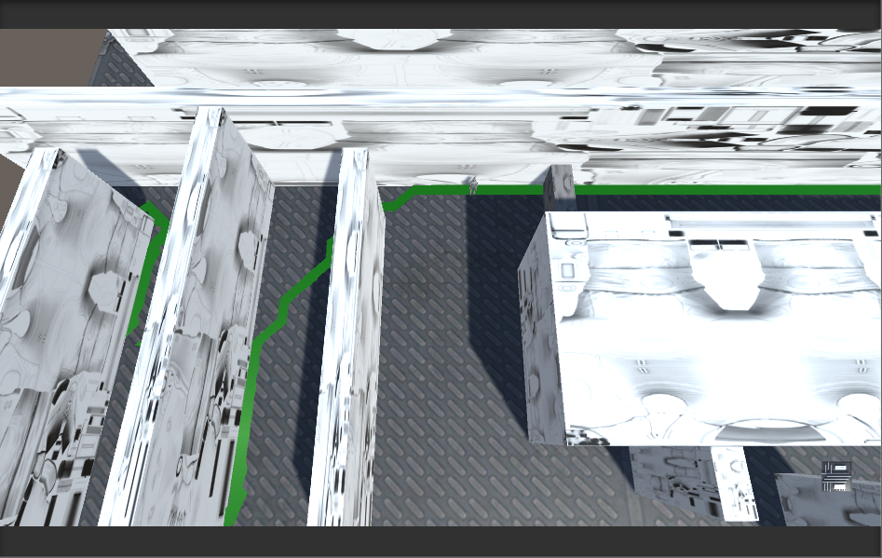

Green line represents the current path our agent will take. This changes as our agent encounters dynamic obstacles in the map.

Dynamic objects are not random yet. They have been placed in areas that we know would obstruct the current path of our agent. Dynamic objects appear only when A* is recalculated and upto 3 times. Since dynamic objects appear at the same place, when moving the agent second time on the map will only add dynamic objects on top of each other.

The console has information on cost of optimal path after all dynamic objects pop up vs the actual cost of the path we took after recalculation. Console also has info on the number of nodes expanded optimally vs number of nodes expanded on recalculation.

The program often runs out of memory usually when it is started after unity is idle for a while. This occurs when it reaches the first dynamic obstacle and A* needs to be recalculated



Works fine again after restarting Unity. Will need to look into this.